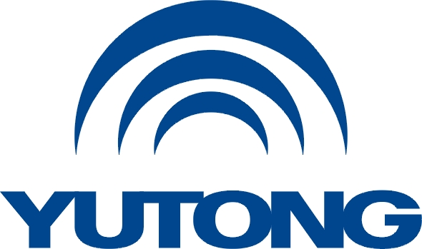

**Media Kit**

**For the Busworld Europe 2025**

**Yutong ESG**

Yutong Bus Co., Ltd.

October, 2025

**Yutong ESG**

**I. Environmental Protection**

Global climate change poses a serious threat to both ecosystems and human health. As a global bus leader, Yutong always adheres to the concept of energy conservation, carbon reduction, green development and operations, and practices environmental protection. Up to now, Yutong has sold more than 200,000 units of new energy buses. The cumulative fuel savings reached approximately 9.6 billion liters, with 1.4 billion cubic meters of natural gas conserved and carbon emissions reduced by about 28.5 million tons, equivalent to planting 140,000 hectares of trees.

Since 2024, Yutong has also launched the “Net Zero Forest” initiative (afforestation), pledging to “plant a tree for every bus sold worldwide”. The first batch of projects was implemented in 2024 across China’s Gansu Province, the UK, Chile, and other locations, planting over 36,000 trees, expected to absorb approximately 18,000 tons of carbon dioxide annually (based on tree species and growth cycles). An estimated 47,000 trees of various species will be planted worldwide in 2025.

In 2024, Yutong launched “Let’s Go Green” initiative to promote eco-friendly travel in response to climate change. The initiative invited passengers to experience green Yutong buses, setting up distinctive landmark or architectural stops for interactions like organized quizzes and Q&A sessions. These efforts aim to deepen public awareness and understanding of green city bus and low-carbon travel. The initiative (Green Mobility Week) was successfully held in Brisbane, Australia in September 2024, followed by in Athens and Thessaloniki, Greece in May 2025. Through partnerships with local customers and dealers, the initiative featured public welfare activities centered on green themes. The initiative not only promoted environmental awareness and enhanced consciousness about energy-efficient driving but also translated the concept of “green operations” from slogan into tangible actions, contributing to a shared green future.

Moreover, Yutong's primary energy sources consist of electricity, natural gas, heat, gasoline, diesel, and hydrogen. In 2024, electricity and natural gas together accounted for approximately 90% of the company’s total comprehensive energy consumption, representing the dominant energy inputs in its production processes. Meanwhile, Yutong has undergone carbon emission verification and certification audits. So far, a total of 50 commercial vehicle models worldwide have been officially released by international EPD, including 17 models from Yutong, reflecting Yutong’s practical commitment to advancing sustainable development in the transport industry.

**II. Social Responsibility**

By the end of 2024, Yutong has donated over $40 million and assisted more than 100,000 people. In 2025, Yutong cooperated with the Pakistan Down Syndrome Association (PDSA) to launch the “Golden Ticket” program, offering free specialized transportation and zoo visits for children with down syndrome while working to create an accessible and sustainable environment.

In 2022, Yutong partnered with Kazakhstan’s government agencies, transportation authorities, and education departments to launch a school bus safety initiative, aiming to enhance public awareness of transportation safety among local residents. In Astana, Karaganda, Aktobe, and Almaty, a series of intriguing and educational traffic safety camp activities have been conducted to teach children about road safety. These activities, such as setting up traffic signs, safety helmet relay races, visual blind spot demonstrations, and emergency drills for school bus incidents, have attracted over 400 children and parents to join and learn essential knowledge about traffic safety.

In 2024, Yutong carried out over 10 public welfare initiatives in China, including the “Student Subsidy Program in Autumn”, “Emergency Incident Relief”, “Public Welfare Campaign on Children Traffic Safety”, and “Endowment Fund”. Throughout the year, the Company donated over 40 million RMB in funds and supplies, benefiting more than 12,500 people. These efforts demonstrate Yutong’s commitment to fulfilling its promise of “contributing to society” through concrete actions.

Yutong has always been committed to the research, development, and promotion of new energy buses. The Company places strong emphasis on environment-related factors such as energy and resource consumption, waste management, and carbon emissions. It also provides a fair and equitable working environment, and safeguards the basic rights and interests of its employees, by carrying out production safety management, employee training and development, compensation and benefits, anti-corruption and anti-bribery measures and so on. In 2024, Yutong achieved a comprehensive WCA assessment score that leads the industry and was certified with the Eco Vadis Silver Medal, proving that Yutong ranks top among globally evaluated companies.